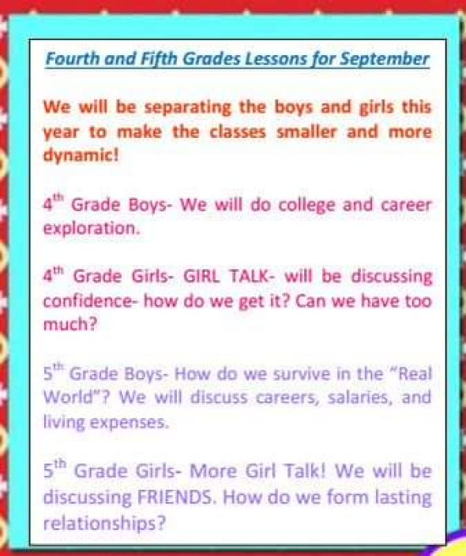
Above is a newsletter that was emailed to parents from Borchardt Elementary School, a school in Plano, Texas. (September, 2015)
Please respond to the following questions on a separate piece of paper to turn in.
1. Complete the “Big 5” for audience, purpose, context, content and theme. Please complete in a chart format.
2. How can language be gender-biased? Please use at least 3 examples from the text to support your response. (Sentence starter: The language used in this newsletter implies/assumes/suggests/responds to…)
3. How does society create or enforce gender stereotypes or roles? Please use at least 2 examples from the text to support your response.

